Monkey and Banana Problem
AIM:
To write a Prolog program to solve the Monkey and Banana problem using state-space representation and logical rules.
ALGORITHMS:
- Start.
- Define the initial state of the monkey, box, and bananas.
- Represent the state using the monkey's position, box position, and whether the monkey has the bananas.
- Define the possible actions: move, push the box, climb the box, and grasp the bananas.
- Check whether the monkey can reach the box.
- If necessary, move the monkey and push the box below the bananas.
- Climb the box and grasp the bananas.
- If the monkey obtains the bananas, display the goal state; otherwise, continue searching for a valid sequence of actions.
- Stop.

CODE:
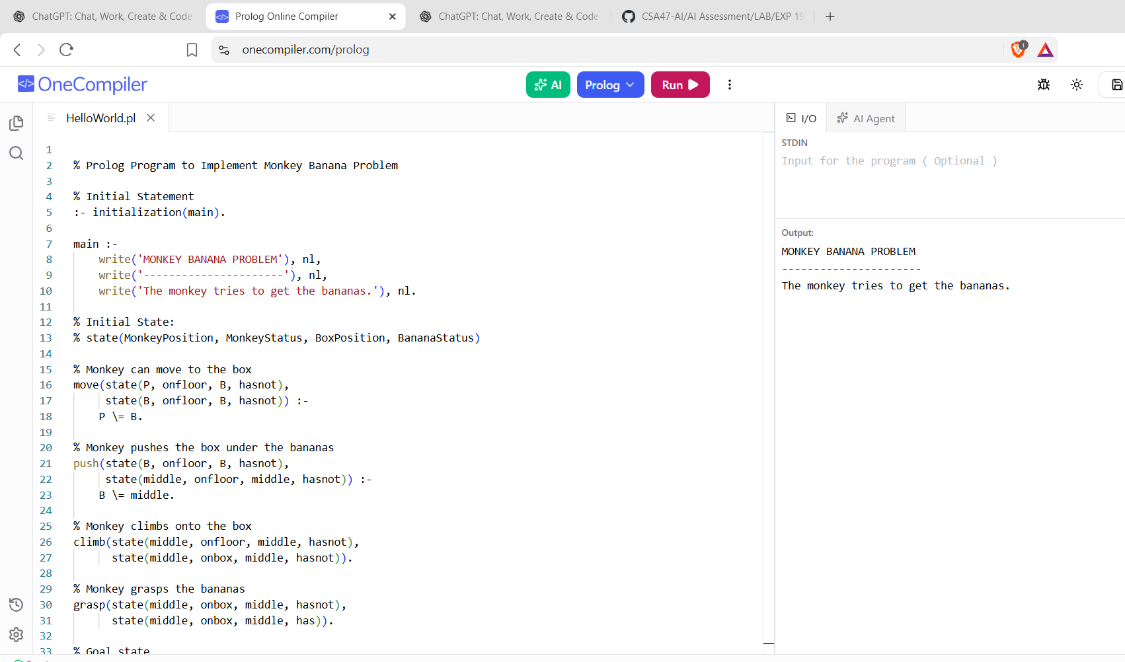
RESULTS:
The program finds a sequence of actions through which the monkey can reach and obtain the banana.

